**Infosys Resource Configurator User Guide**

**Intelligent Bot Management/Version: 1.1**

**Sep-2022**

COPYRIGHT NOTICE

© 2022 Infosys Limited, Bangalore, India. All Rights Reserved. Infosys believes the information in this document is accurate as of its publication date; such information is subject to change without notice. Infosys acknowledges the proprietary rights of other companies to the trademarks, product names and such other intellectual property rights mentioned in this document. Except as expressly permitted, neither this documentation nor any part of it may be reproduced, stored in a retrieval system, or transmitted in any form or by any means, electronic, mechanical, printing, photocopying, recording or otherwise, without the prior permission of Infosys Limited and/or any named intellectual property rights holders under this document.

Infosys Limited

Electronic City,

Hosur Road,

Bangalore 560 100

India.

Telephone: 91 80 2852 0261

Fax: 91 80 2852 0362

Website: http://www.infosys.com

**TABLE OF CONTENTS**

1. Introduction 4

2. Screens 4

2.1.1 Infosys Resource Configuration Demo Portal 4

3. Demo Steps 5

3.1.1 Meta configuration 5

3.1.2 Action Configuration…………………………………………………………………………………………………..10

3.1.2.1 Secure Action parameters……………………………………………………………………...............12

3.1.3 Monitoring configuration 14

3.1.4 Monitoring plan 15

3.1.5 Remediation Plan………………………………………………………………………………………………………..16

3.1.6 Remediation Configuration…………………………………………………………………………………………19

3.1.7 Anomaly Configuration………………………………………………………………………………………………..21

3.1.8 Auto Configuration………………………………………………………………………………………………………22

3.1.9 Resource Model 23

# Introduction

This document helps to take demo of Intelligent Bot Management Solution

# Screens

* Meta Configuration
* Action Configuration
* Monitoring configuration
* Monitoring plan
* Remediation Plan
* Remediation Configuration
* Anomaly Configuration
* Auto Configuration
* Resource Model

### Infosys Resource Configuration Demo Portal

In this portal user can do the following actions

* In meta configuration screen, User can add resource mappings and add and update attributes to the resource.
* In the Action Configuration, user can add/update Actions.
* User can add/update monitoring configurations
* Add/update monitoring plans
* In Remediation Plan screen, User can add/update Remediation plan.
* In Remediation Configuration screen, user can map a remediation plan to a monitoring plan for a resource type.
* In the Anomaly Configuration, user can add/update rules for a platform and its resource types.
* In the Discovery, User can discover a particular Platform.
* In the resource configuration screen for any resource user can modify configuration parameters, add/modify observable remediation plans, activate deactivate resources and child resources, add resources and parameters to existing resources.

# Demo Steps

### Meta configuration

Step: Open <http://localhost/superbotapp/#/home> URL and got to left side menu and click on configuration => meta configuration.

* In the meta configuration screen, we can do mapping of resources and adding and updating of attributes to the resources.
* Click on configuration and select meta configuration.

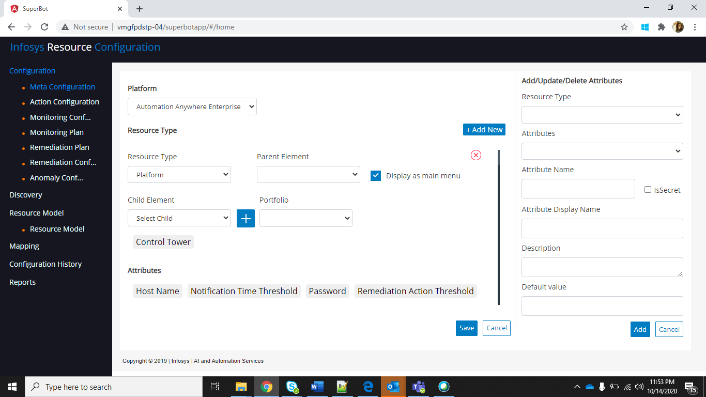

* To add mapping click on “add new” button

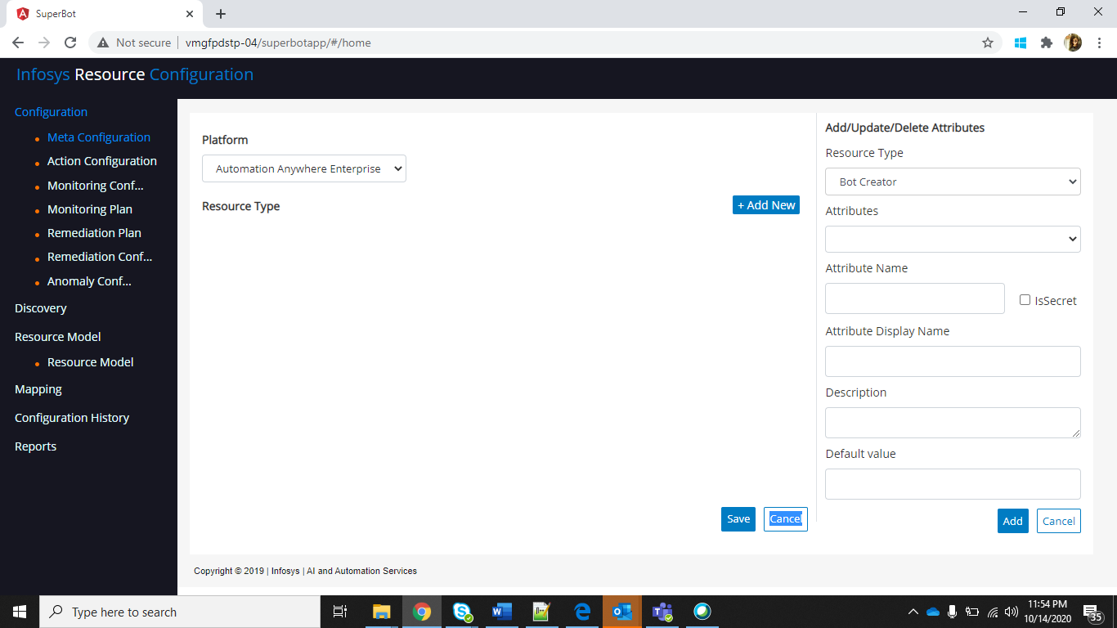

* Select resource, parent and add children and click on save changes.

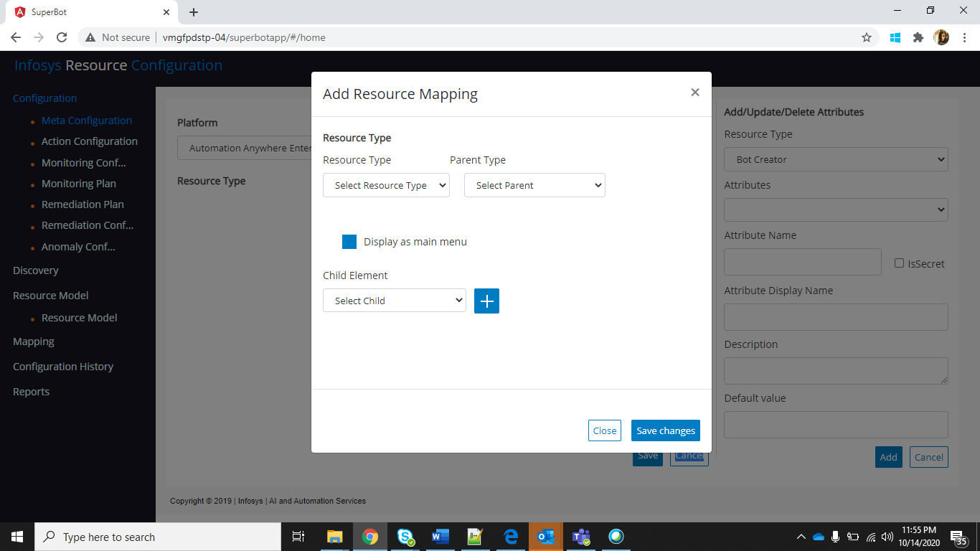

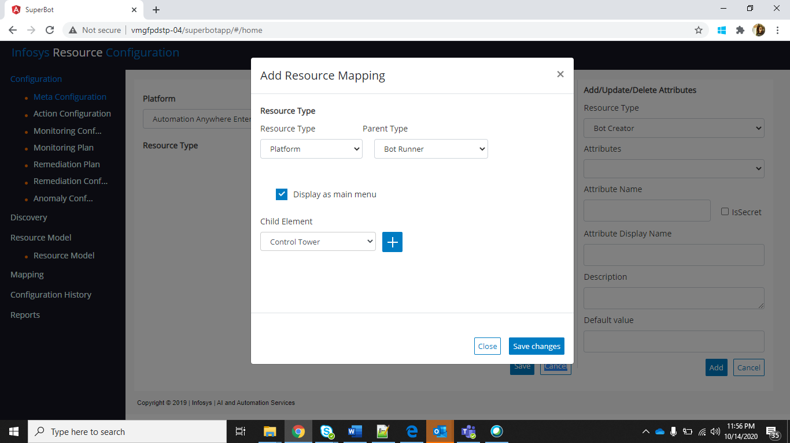

* Click on save

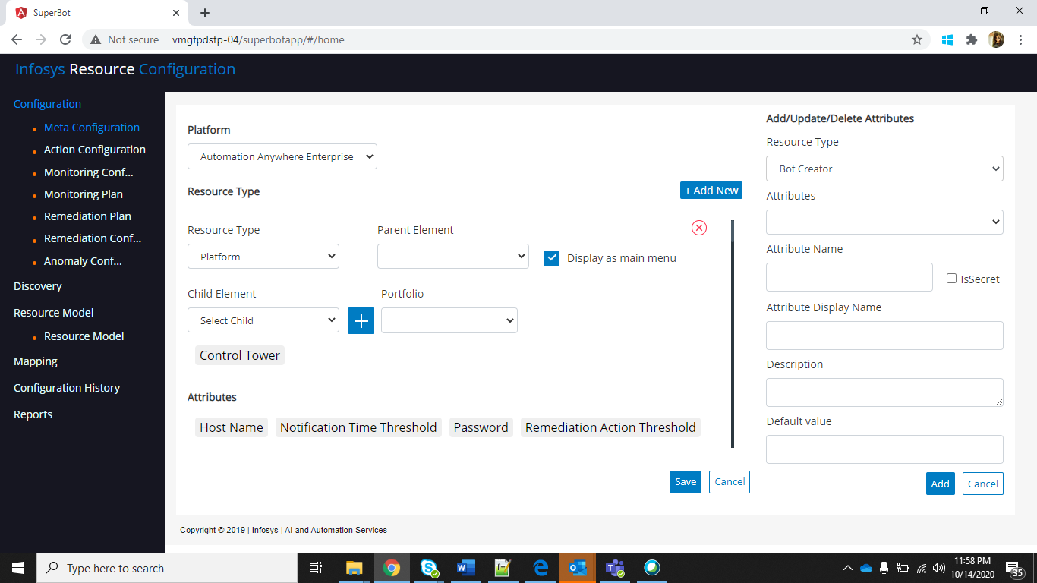

* To delete mapping click on delete icon and click on save.

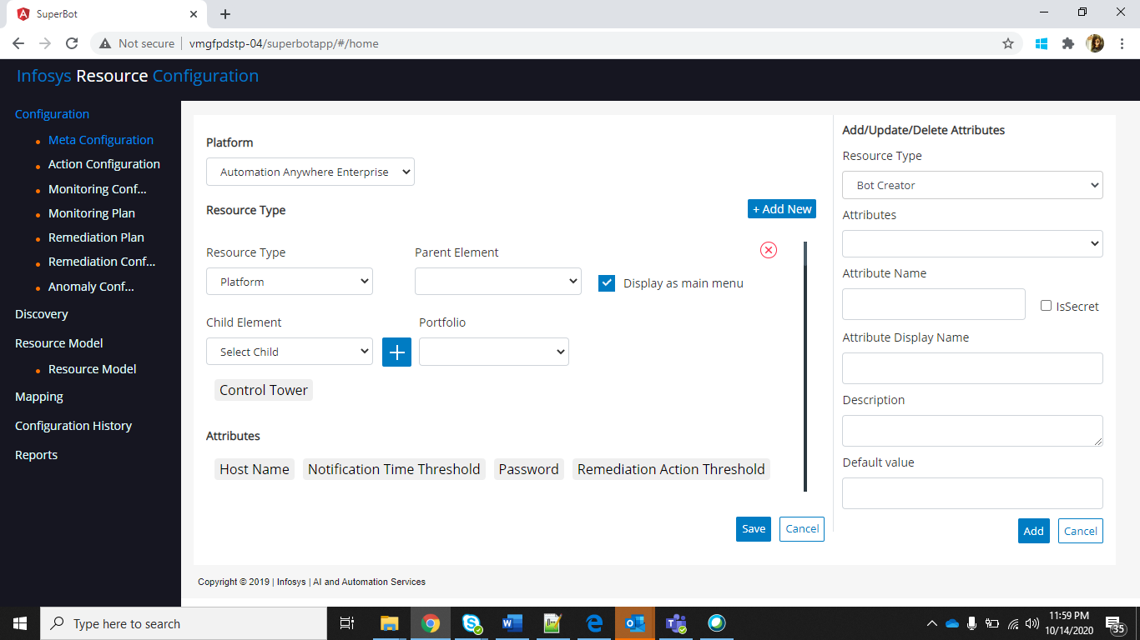

* To delete or update attributes click on attribute and details will be populated in right side section.

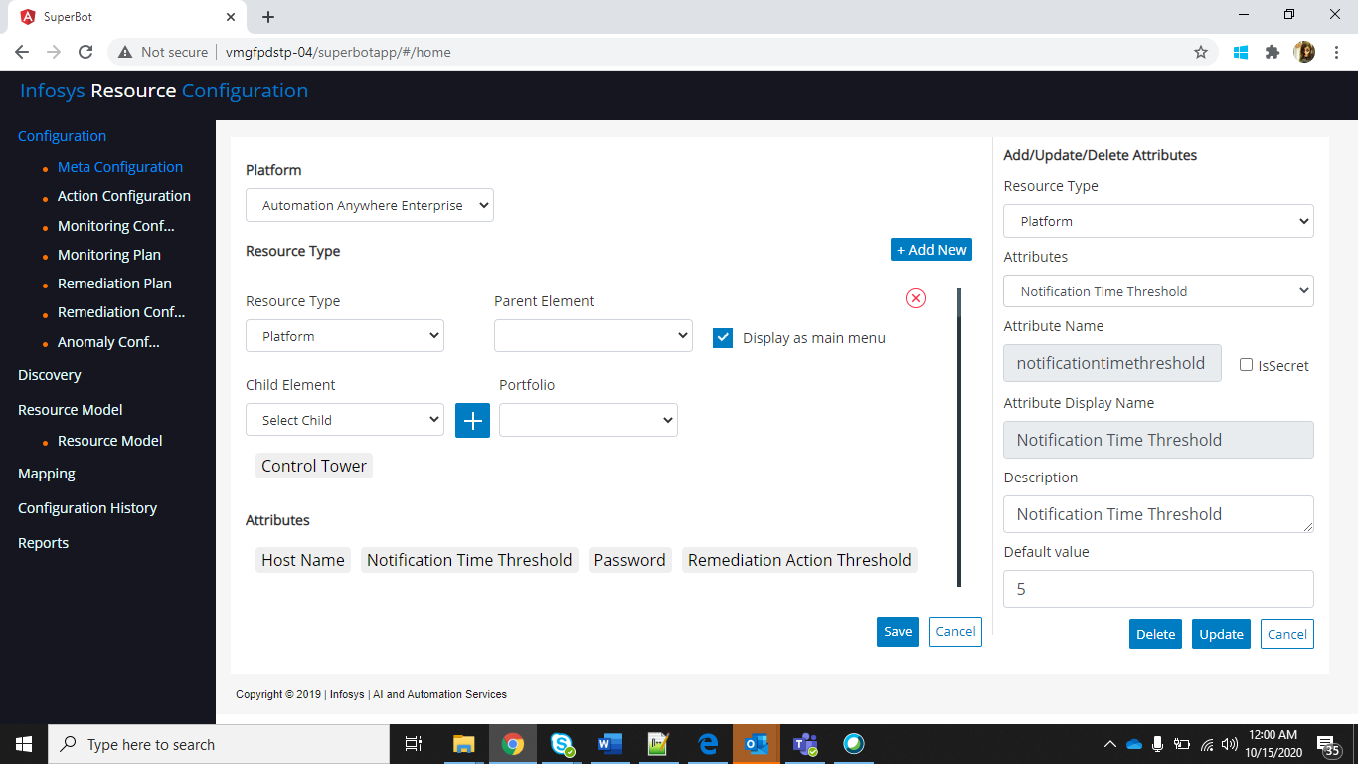

* To add attributes/parameters to resource and fill attribute name, attribute display name, description and click on save

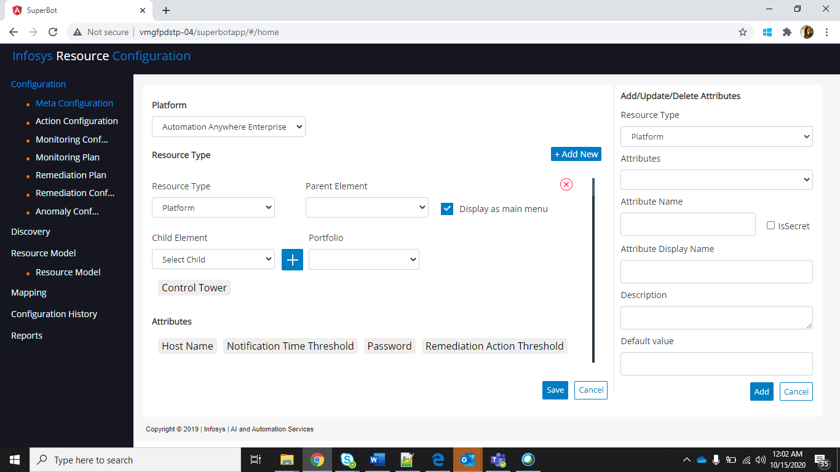

* To Update an attribute, select resource and available attributes will be populated and select any attribute and update description and delete attribute.

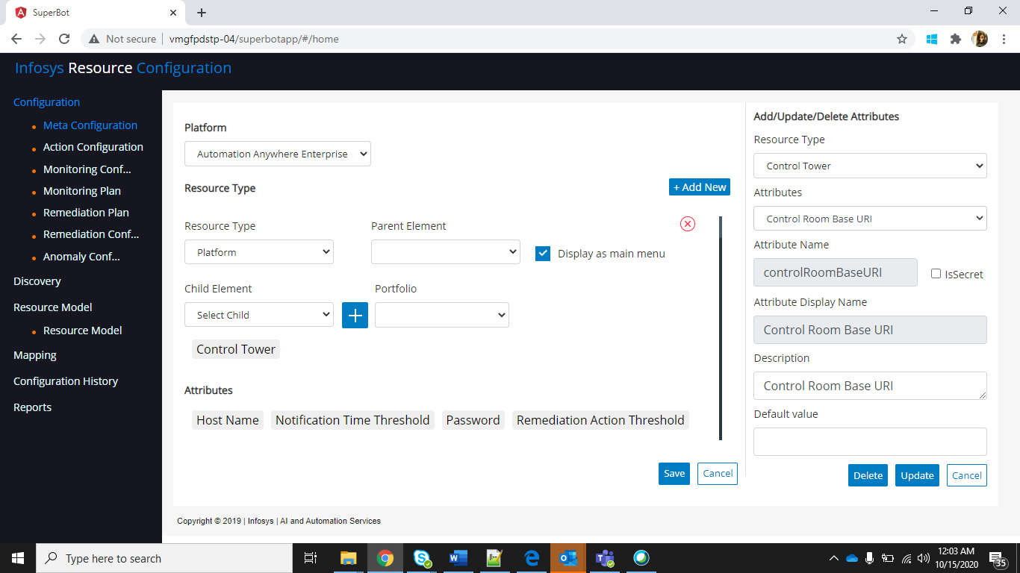

* We can add child to existing mapping, to do that select child and click on plus icon and click on save

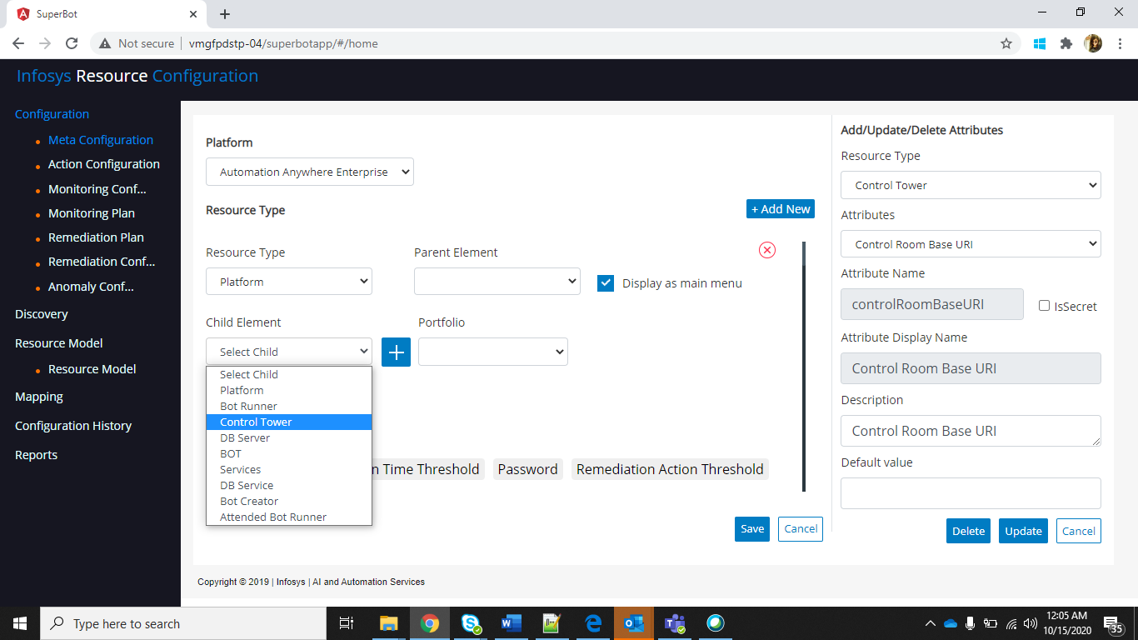

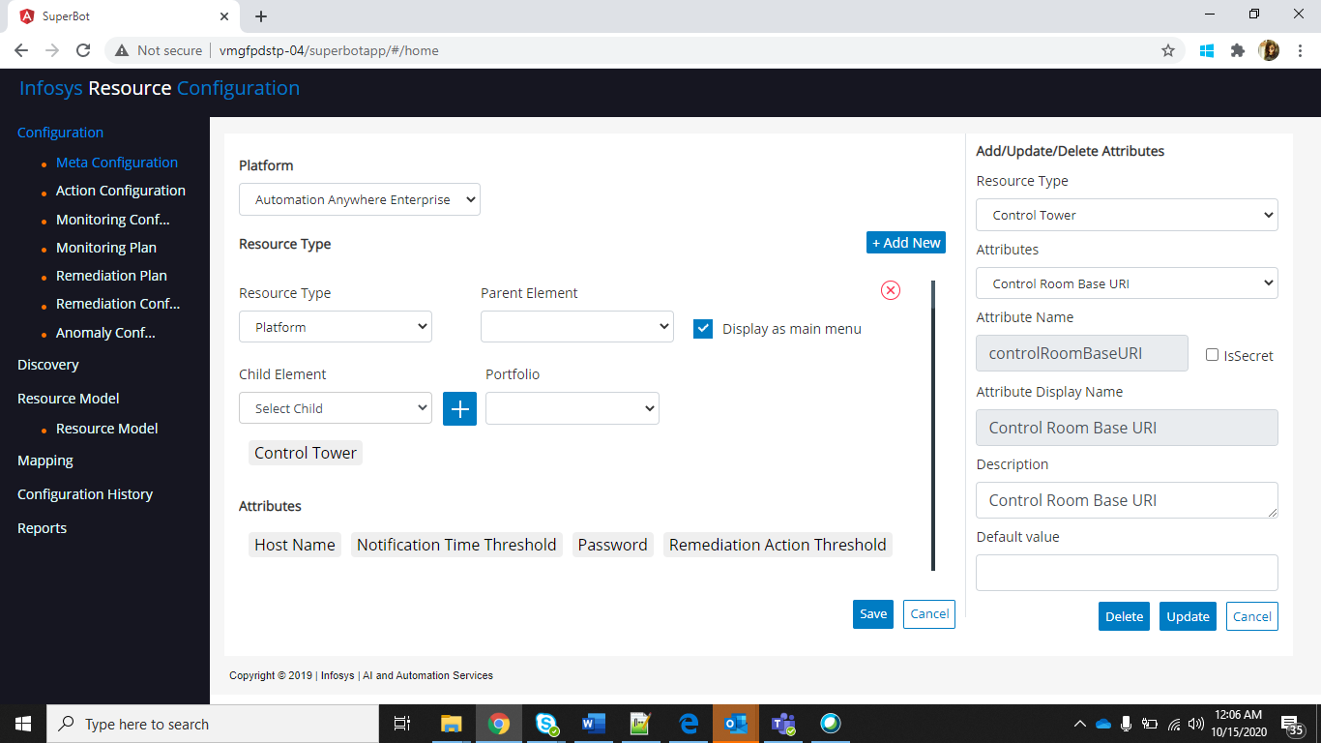

### Action Configuration

Step: On the left side menu, select configuration and click on Action configuration.

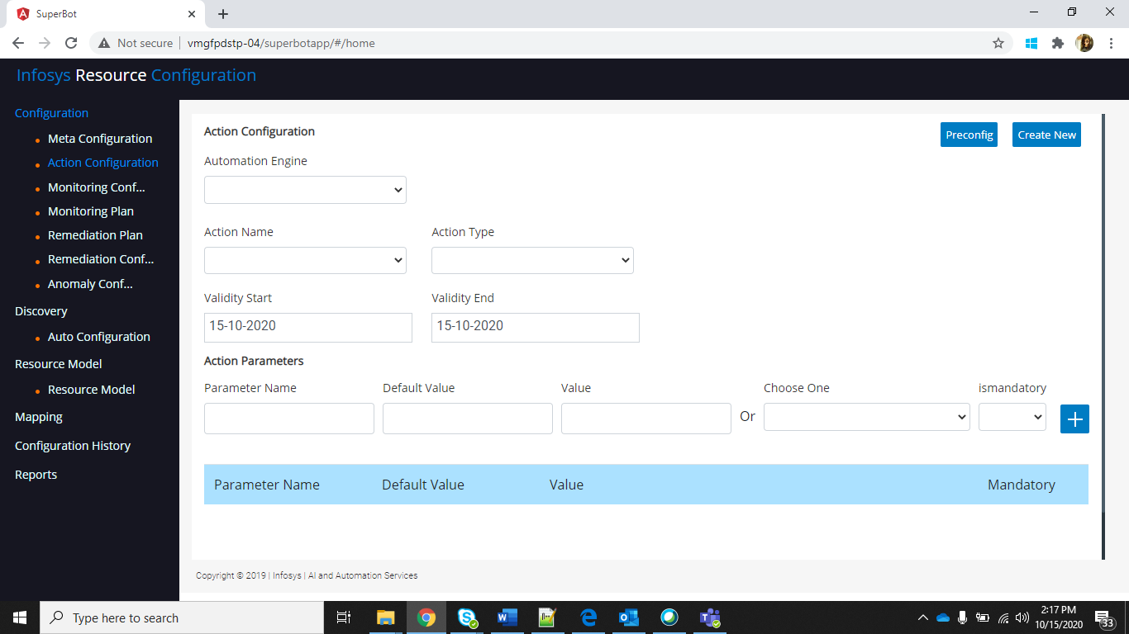

* Enter the **Automation Engine Name**, **Base URL**, **Category Service Name**, **Script Detail Service Name**.
* Click on “**Configure**”.

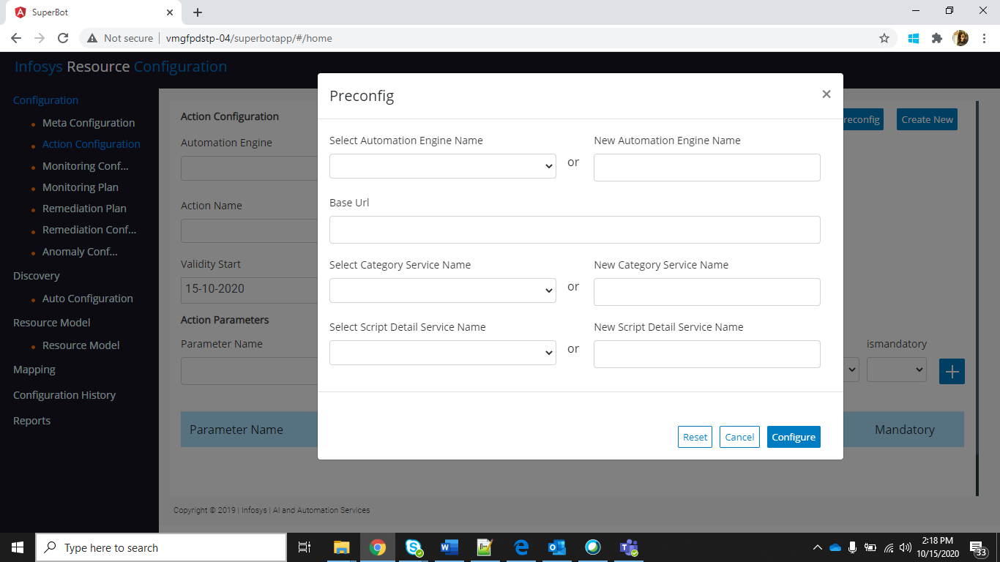

* To add a new Action, click on “**Create New**” button.

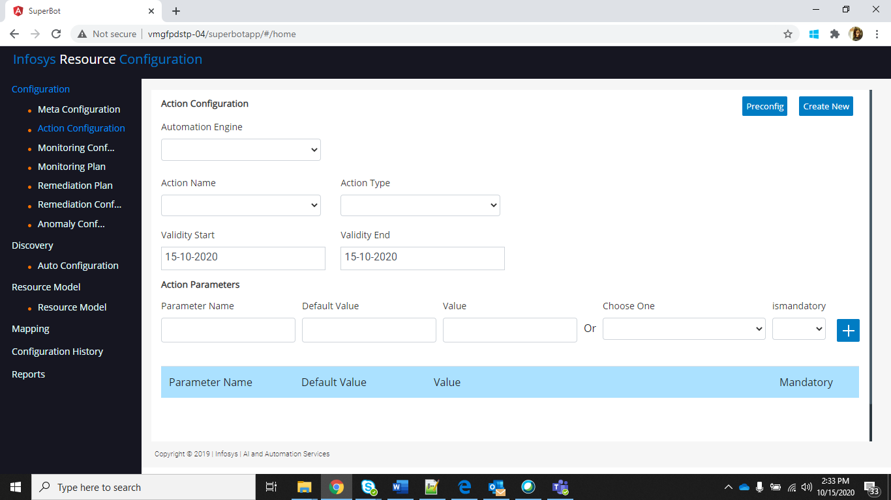

* Select the **Automation Engine**

#### Secure Action parameters

* All monitoring and remediation plans are associated with actions to be performed for monitoring and remediating a resource or a service.



* User can add action parameters for actions by clicking on the ‘**+**’ icon in the Action Configuration.
* To secure action parameter values, associate with resource_attribute.AttributeValue for both new and existing parameters.



* These resource attribute values will be picked up from respective resource from resource model where we have an option to secure the value by setting IsSecret to YES.
* If IsSecret value is set to YES, then the value will be encrypted and shown as masked string in the resource configurator thereby securing it i.e., not disclosing the data/values to the user.



### Monitoring configuration

Step: On the left side menu, select configuration and click on Monitoring configuration.

* First time, we need to perform the following steps
  + Click on “Create new” button, to add one monitoring configuration
  + Give Metric name, unit of measure, validity start, validity end and select date type and click on Add.

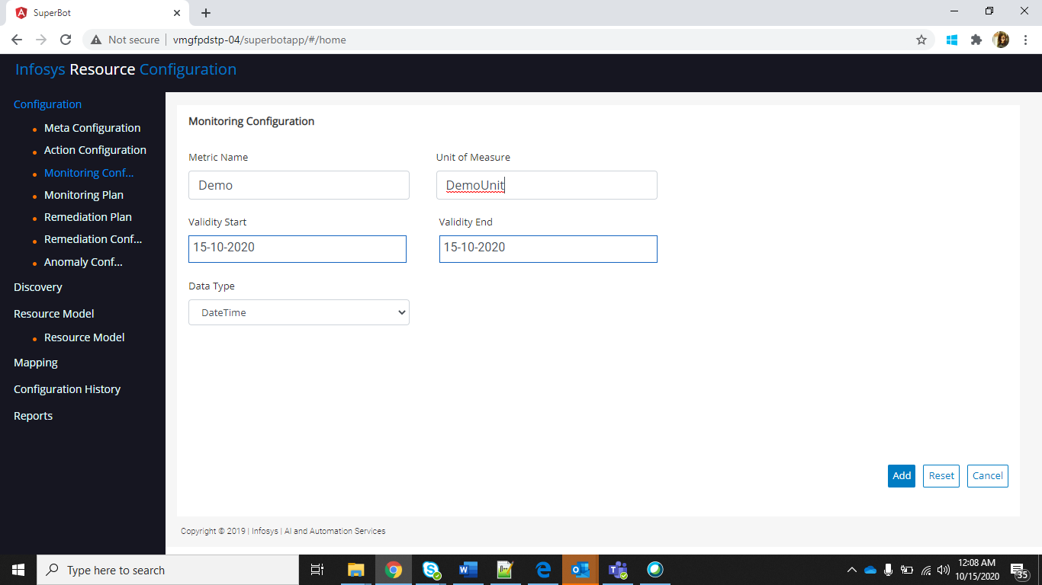

* To Update existing monitoring configuration, Click on Reset
  + Select one Metric Name and details will be populated
  + Modify details and click on Update.

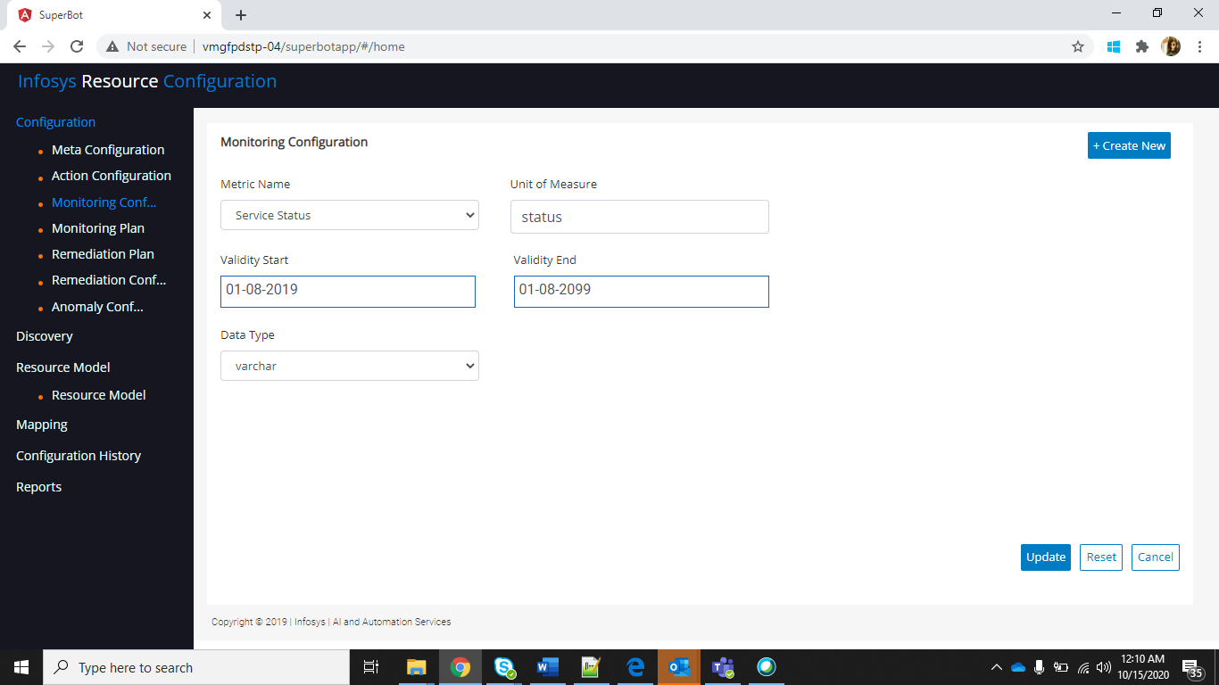

### Monitoring plan

Step: On the left side menu, select configuration and click on Monitoring plan.

* First time, we need to perform the following steps
  + Click on “Create new” button, to create Monitoring plan
  + Give Plan name, select a metric for resource type and action.
  + Click on “Add”.

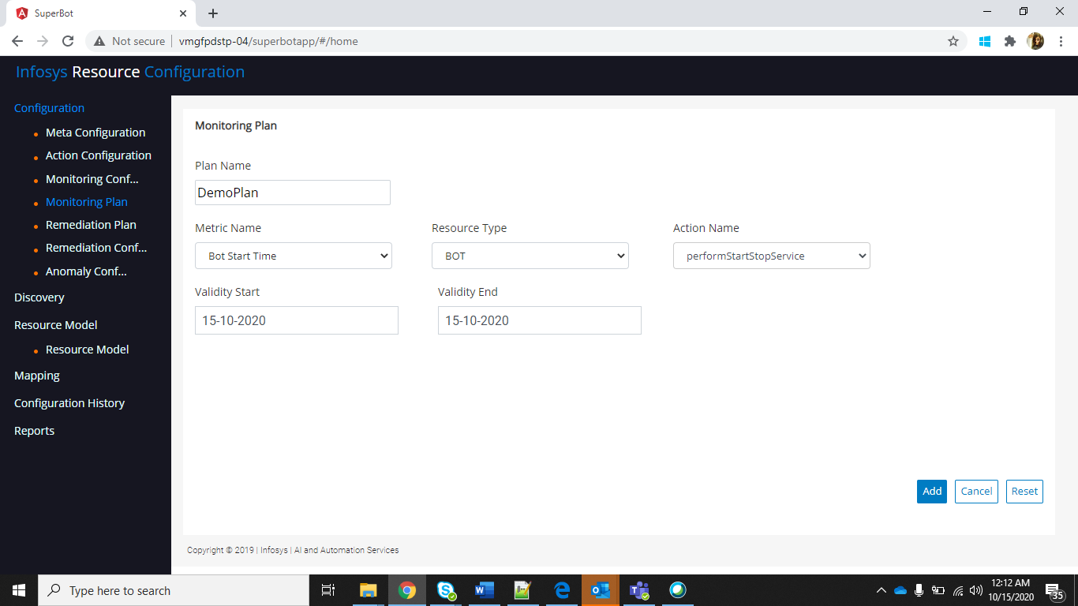

* To Update existing monitoring plan, Click on Reset
  + Select monitoring plan and details will be populated
  + Modify details and click on “Update”.

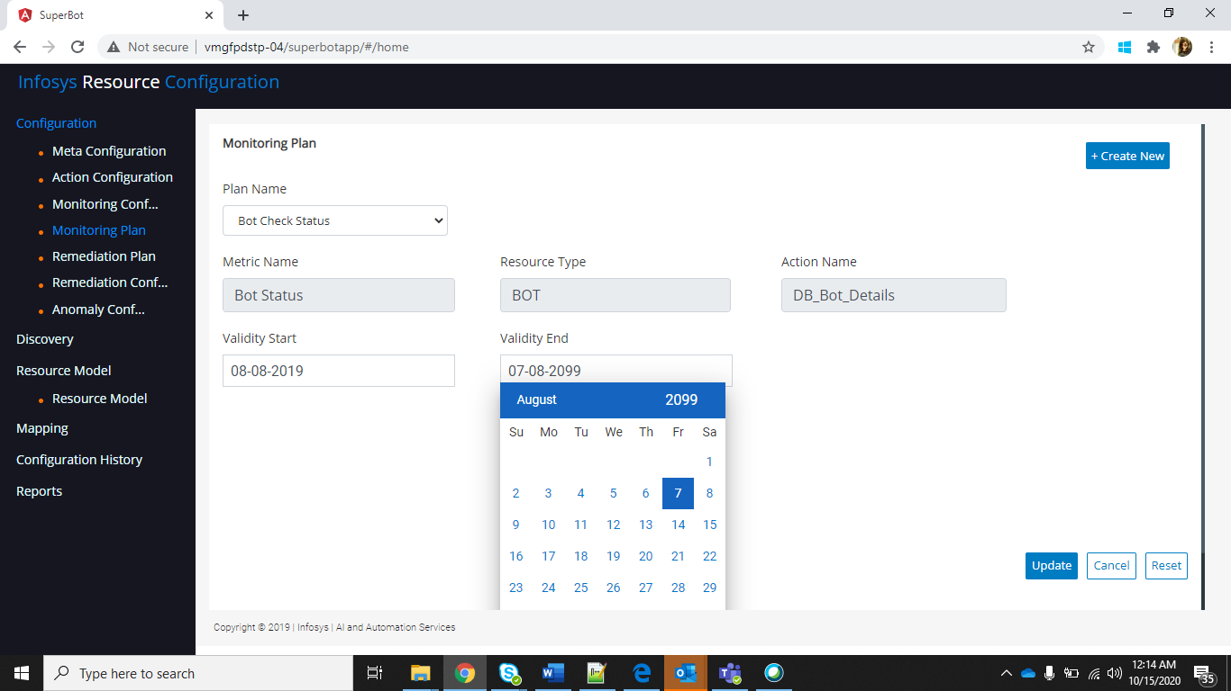

### Remediation Plan

Step: On the left side menu select Configuration and click on Remediation plan.

* Select the remediation plan from the list of remediation plans.

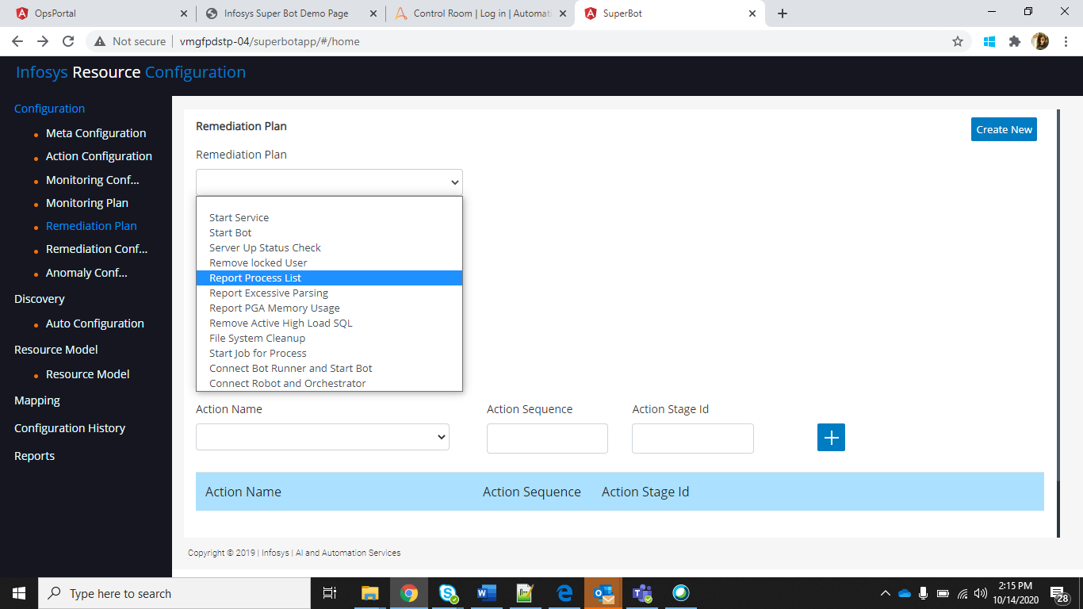

* The **Description** and **User Defined** field will be auto populated and the list of action associated with the particular remediation plan with their sequence and Stage ID will be displayed under **Action name, Action Sequence** and **Action Stage ID**.

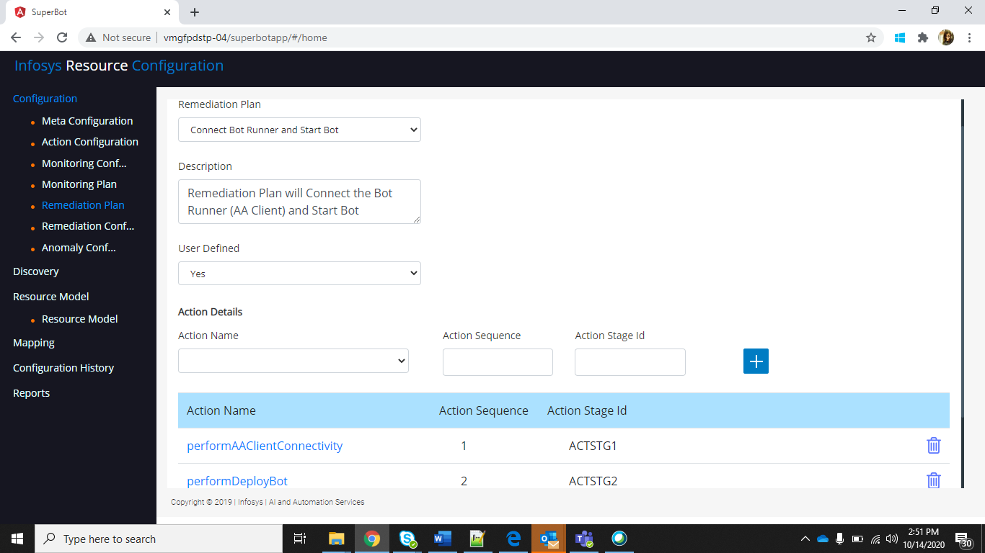

* For adding an action to a particular Remediation Plan,

Under **Action Details,**user can Select the **Action Name** and enter the **Action Sequence** and **Action Stage ID** .

* Click on the add button.

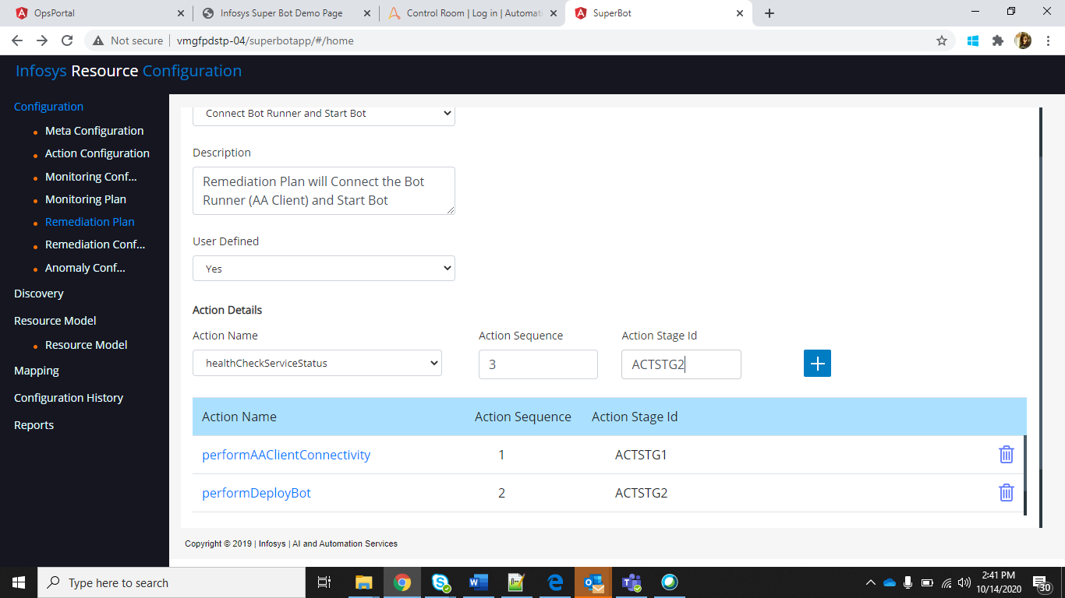

* The Specified action will be added in the action Name List of the specific Remediation Plan.
* Click on **Save** button.

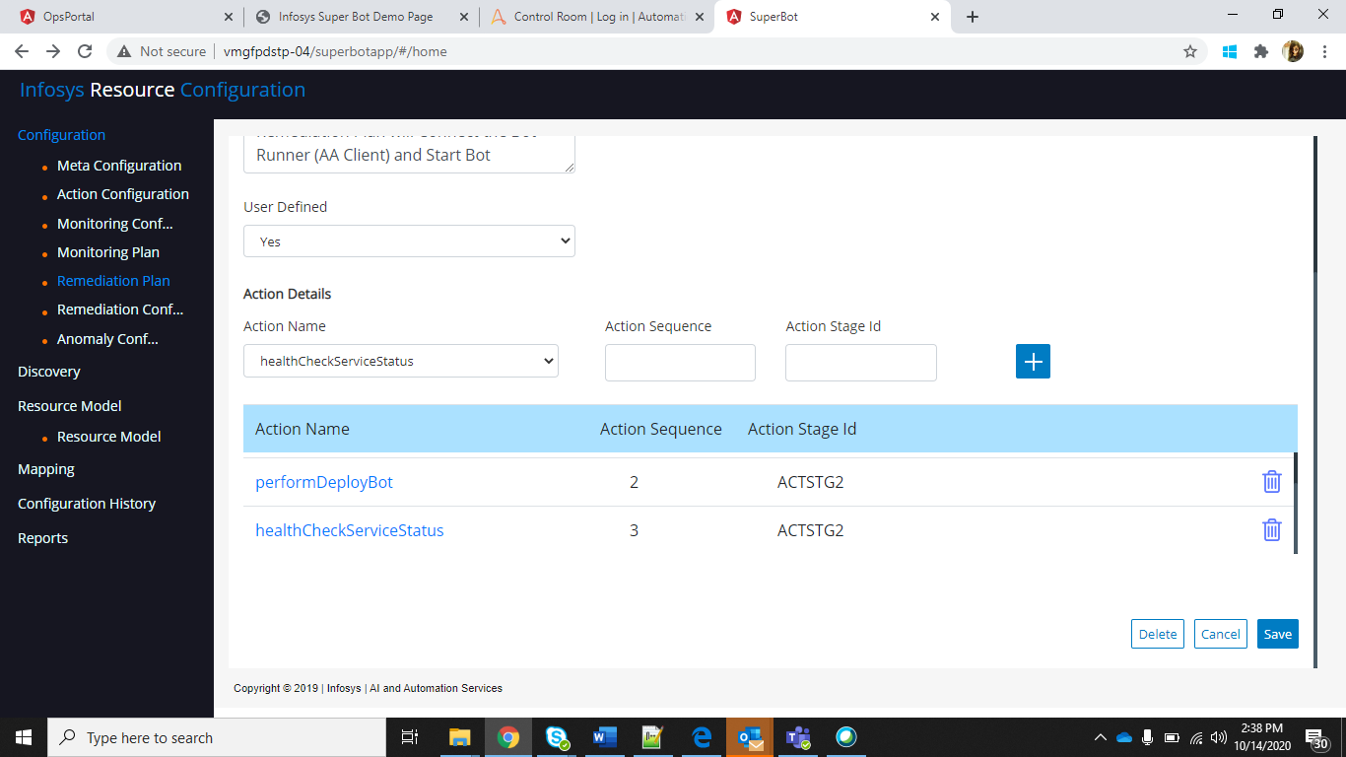

* For creating a new Remediation Plan, Click the **Create New** button in the upper right corner.

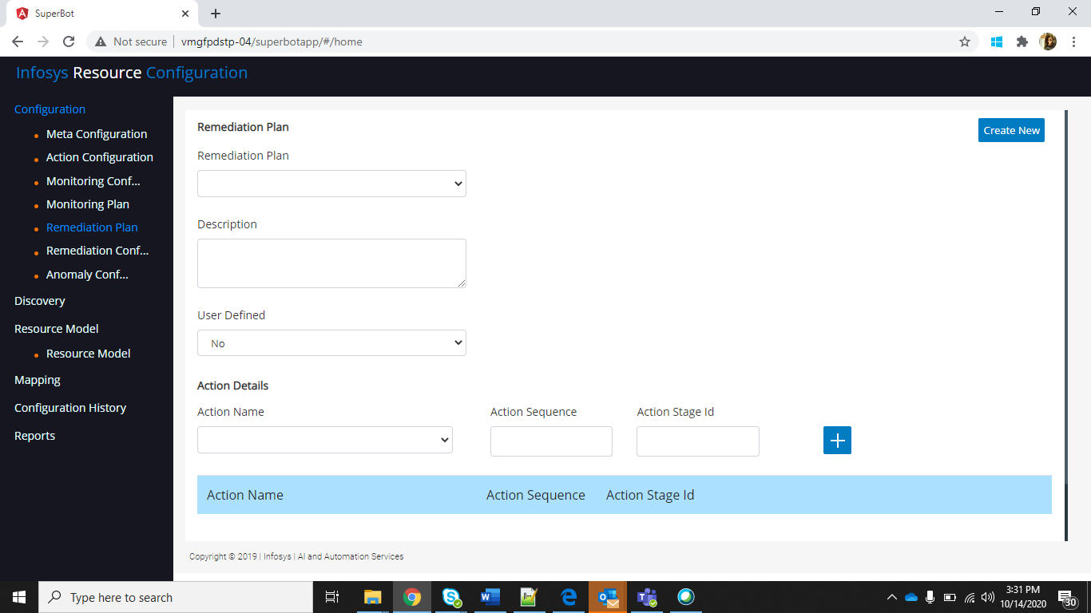

* User can enter the name of the Remediation plan , Description ,set User Defined field as **“Yes”**.
* For adding actions to the plan, fill in the action Details and click **Add** Button.
* Click **“Save”**.

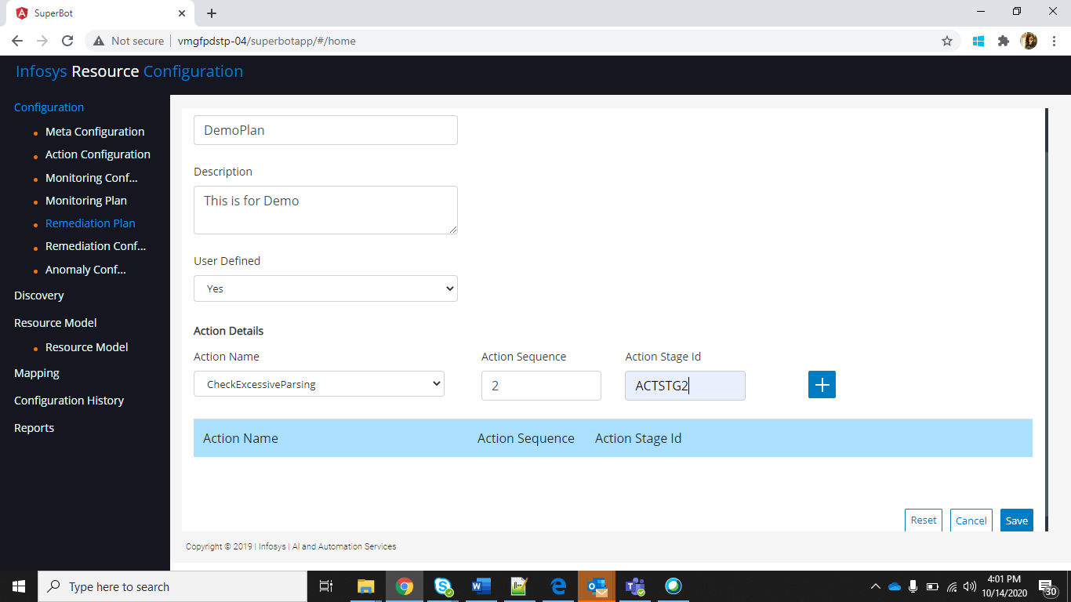

### Remediation Configuration

Mapping between Monitoring Plan and Remediation Plan for a particular resource type.

Step: On the left side menu select Configuration and click on Remediation Configuration.

* Select the **Resource Type**, **Monitoring Plan** and the **Remediation Plan**, **Validity start** **date** and **Validity End Date.**

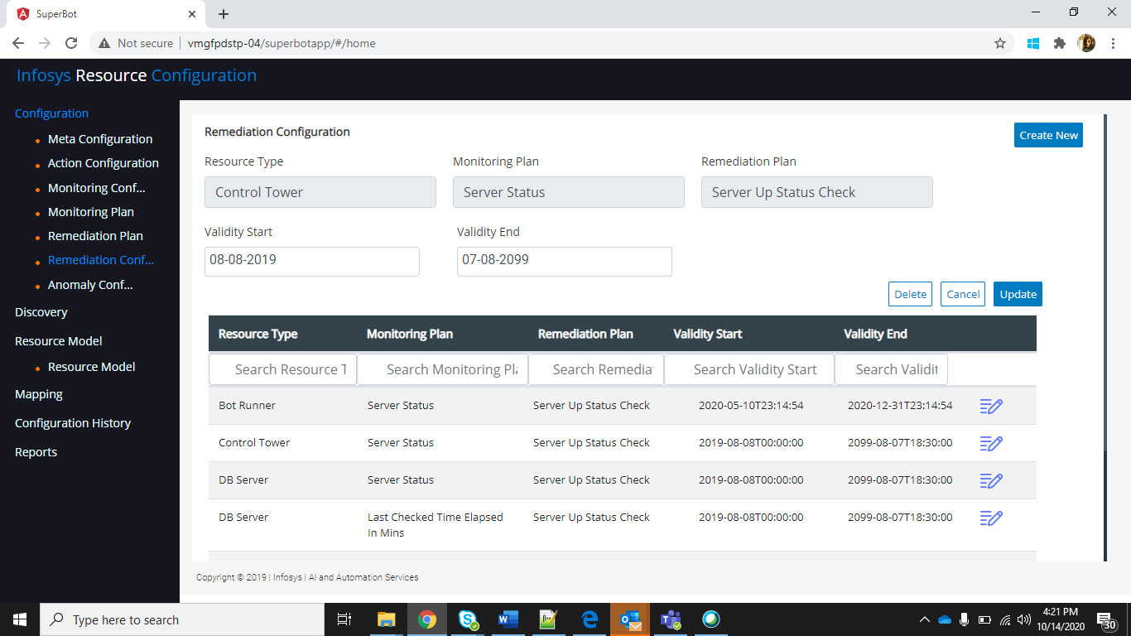

* User can also search for a specific **Resource Type**, **Remediation plan, Monitoring Plan** and **Start /End Date.**
* The **Validity start** and **Validity End** fields can be updated using the update option.

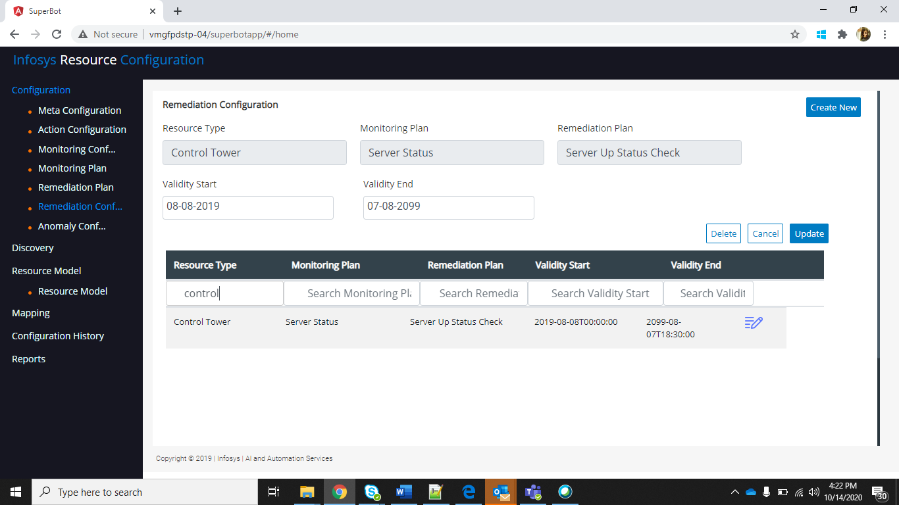

* For creating a new Mapping between Monitoring plan and Remediation Plan for a resource type, Click on **Create New** Button in the upper right corner.

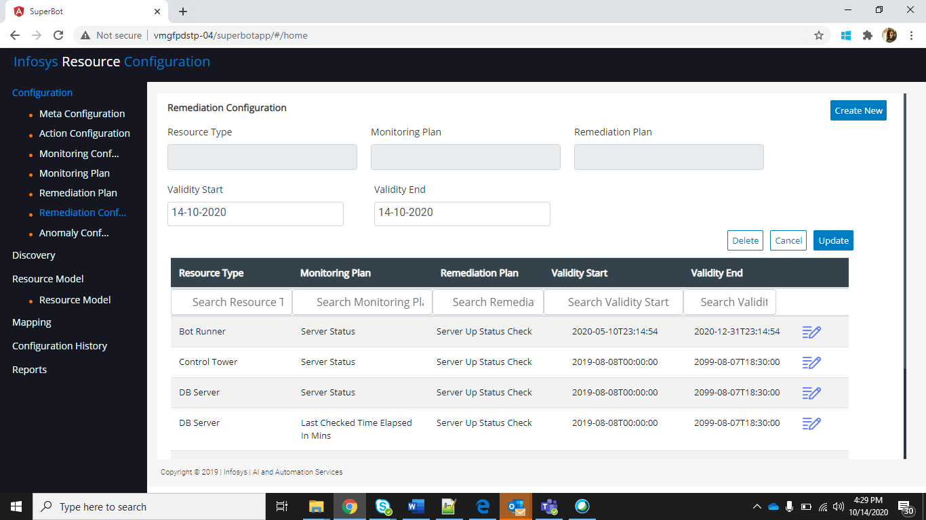

* Populate the values of Resource type, Monitoring plan, Remediation plan and Start/End date.
* Click on **Add** button.

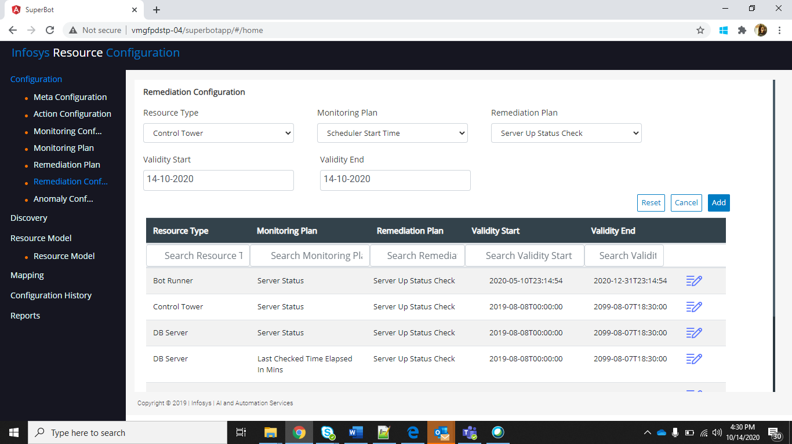

### Anomaly Configuration

Step: On the left side menu select Configuration and click on Anomaly Configuration.

* Select **Platform Instance Name**, **Metric Name** and **Resource Type**.
* The **ResourceName**, **ResourceTypeName**, **MetricName**, **Operator** and the **Lower**/ **Upper** Threshold values will be displayed.

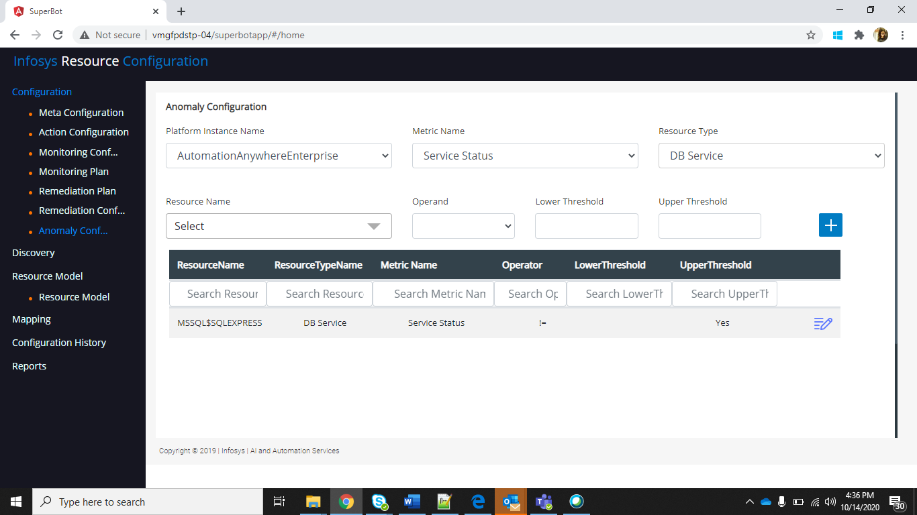

* For adding a new Anomaly, select the **ResourceName**, **Operand** and **Lower/Upper Threshold** values.
* Click the **add** button.

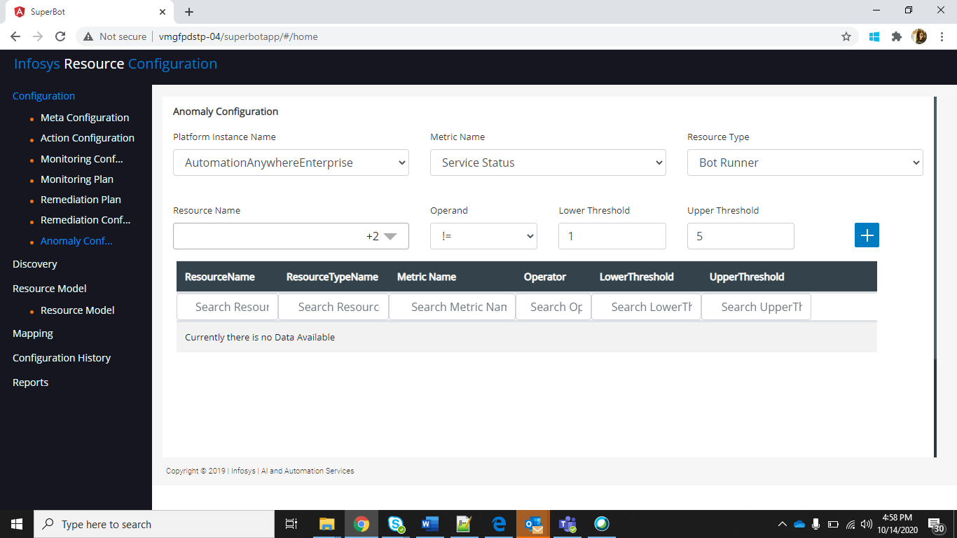

### Discovery- Auto Configuration

Step: On the left side menu select Discovery and click on Auto Configuration.

* Select the **Platform Type.**

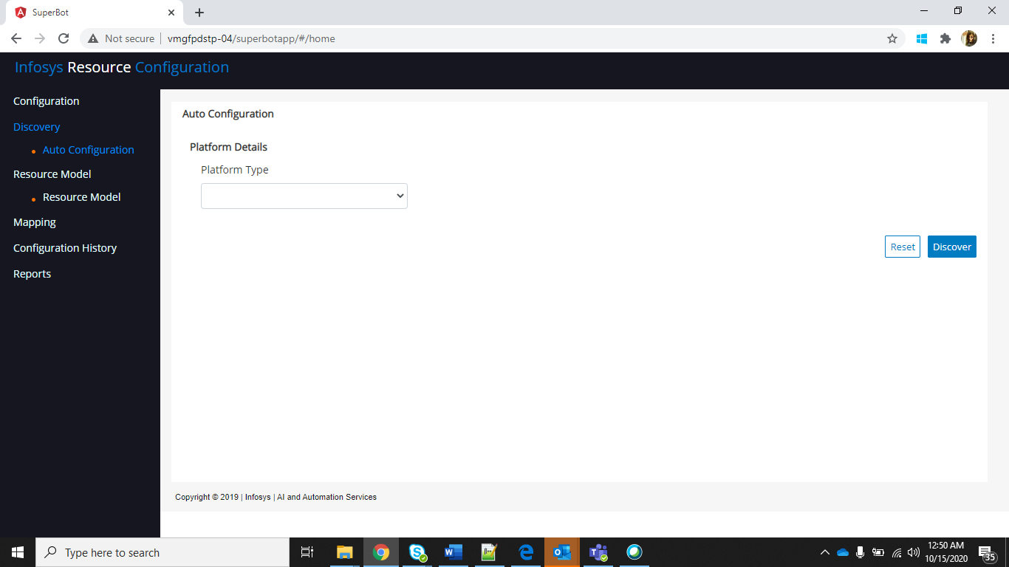

* Populate the details according to the selected Platform Type.

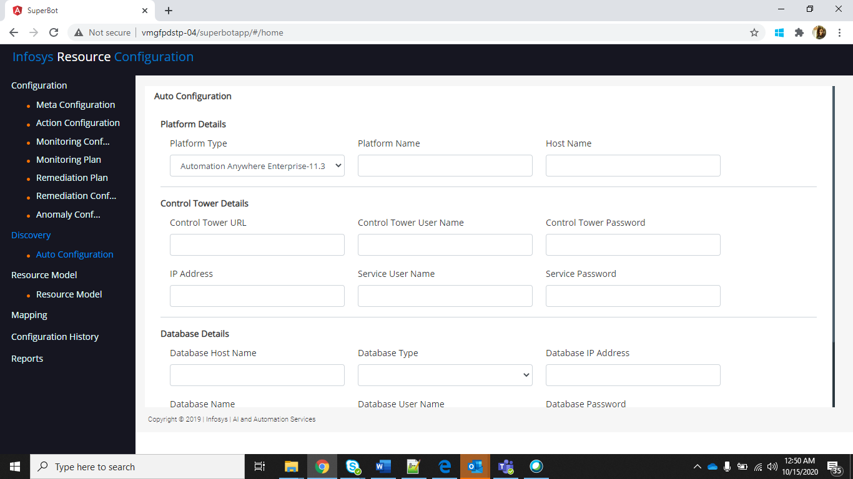

* Click on “**Discover**”.

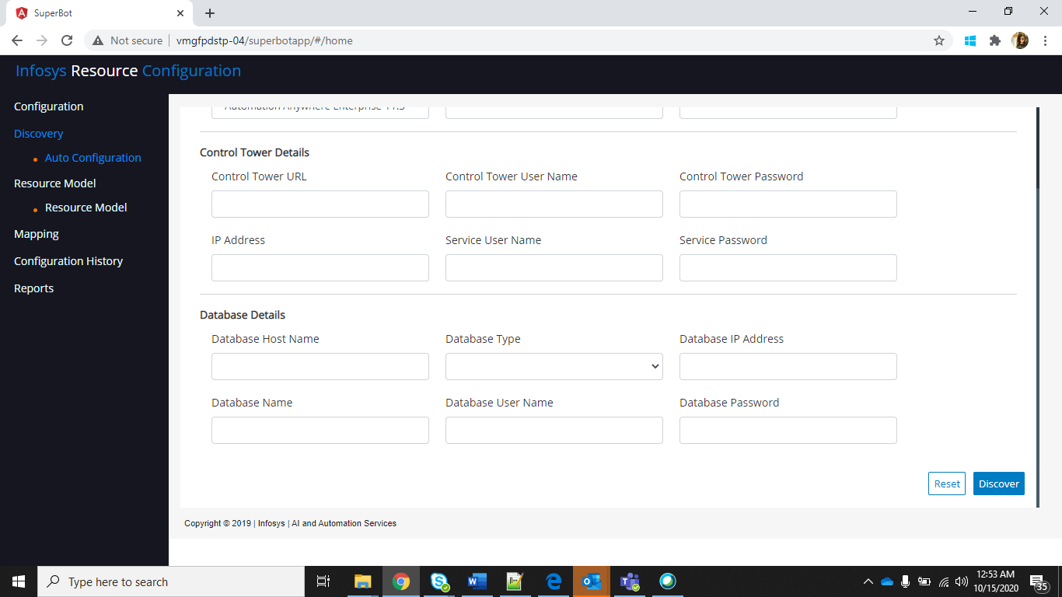

### Resource Configuration

Step: On the left side menu select Resource Model and click on **Resource model**

* As per existing mappings all the resources will be displayed as menu (if display as main menu selected in meta configuration screen)
* To Activate/Deactivate a Resource, click on the **Activate/Deactivate** Button.

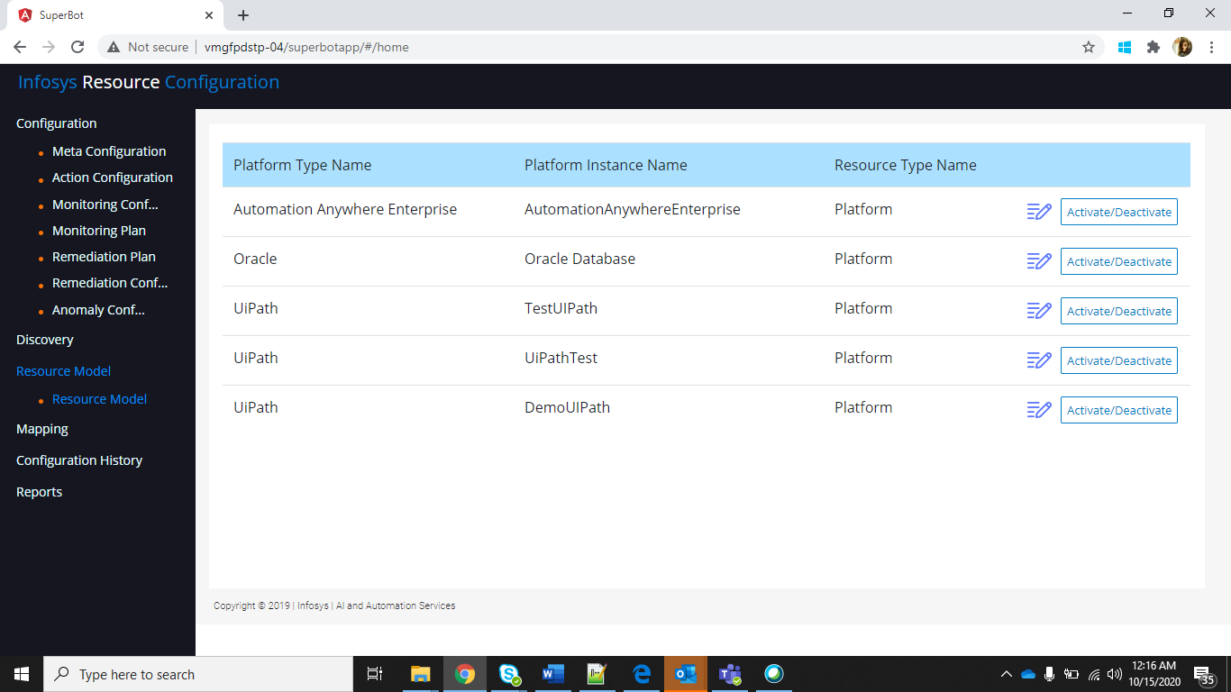

* Select the **Resource type**, **Parent Resource** and click on **Save**.

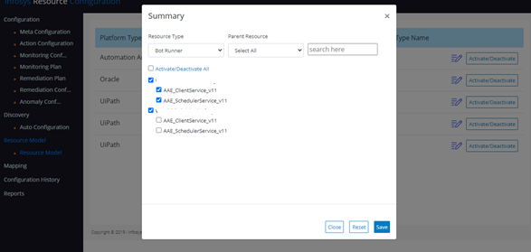

* User can modify configuration parameters
* To add resource, click on plus icon and a popup will be displayed with three options

1. Add Parameter
2. Add Resource
3. Add Observable - Remediation plan

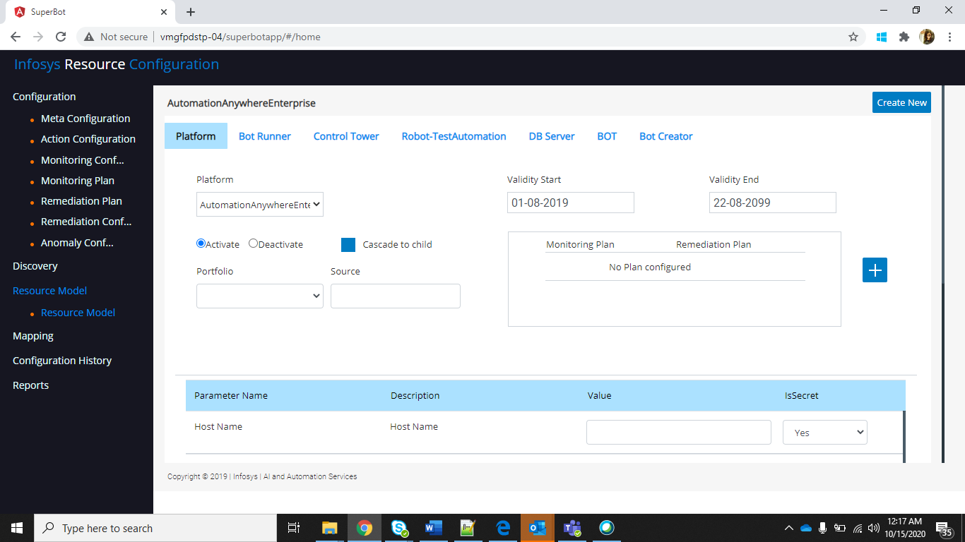

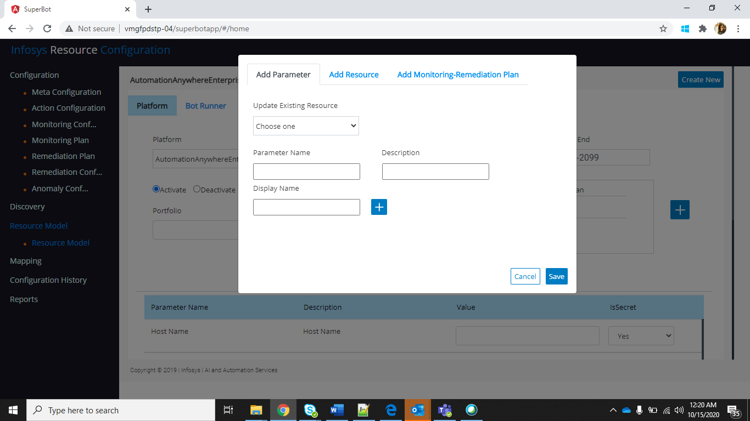

* In add parameter section an option is provided to add parameters to existing resources

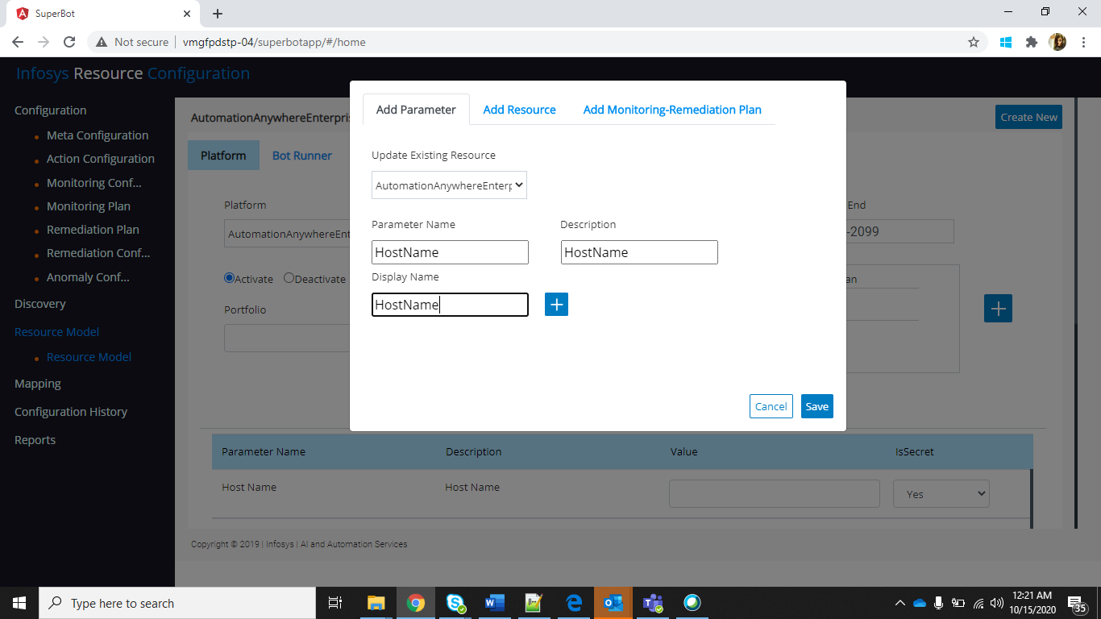

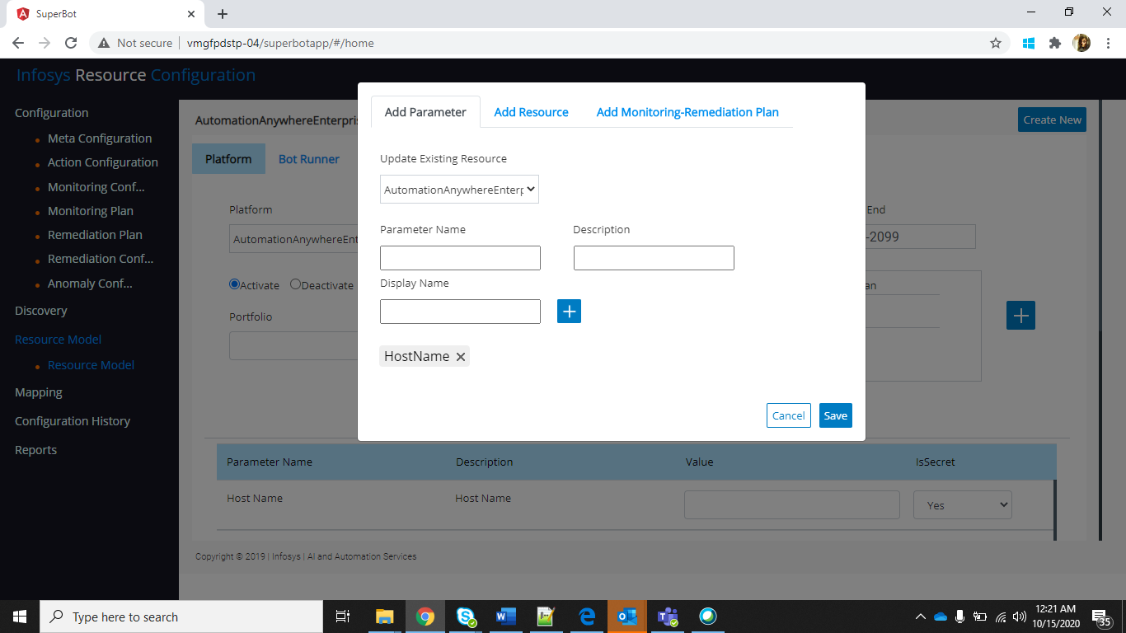

* In Add resource section user can add resource and while adding we can import current resource parameters also.

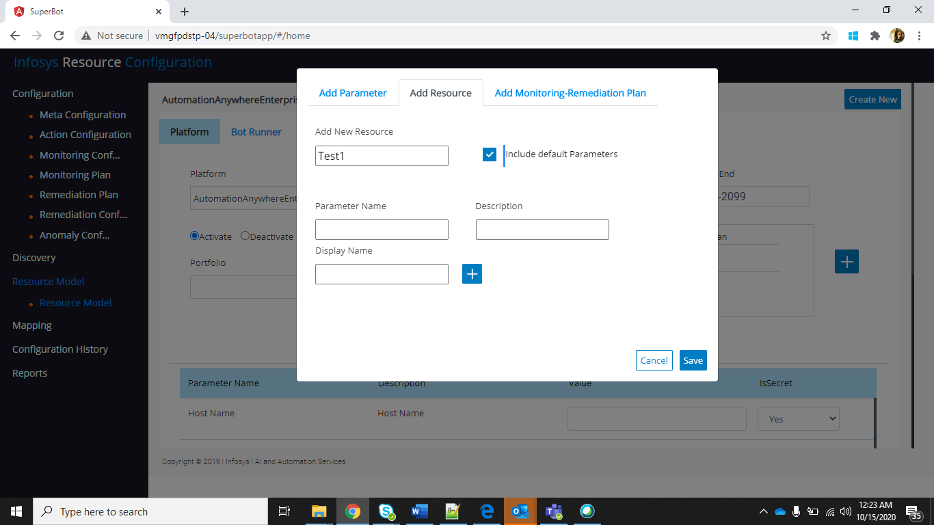

* In add observable – Remediation section resource level plans will be shown, and we can add them by selecting check box and click on save.
* All three options will be available to child also.
* After modifications click on Update button.